Installing and using the SystemLink Python APIs

1. Install the SystemLink Python support
   1. Option 1 - Installing it locally on a system
      1. Use this link to download the SystemLink Python 3.6 distribution package
      2. <http://download.ni.com/support/nipkg/pool/ni-s/ni-systemlink-python-3.6/18.2.0/ni-systemlink-python-3.6_18.2.0.49152-0+f0_windows_x64.nipkg>
      3. Double-click on the package to install
   2. Option 2 – Use SystemLink to remotely deploy it to sever testers
      1. Open the SystemLink Web Interface
      2. Launch the Package Repository application
      3. Create a new feed called something like “SystemLink Python Support”
      4. From the “SystemLink Python Support” feed click the Add button under the Packages section and select the “Import Packages from Remote Feeds” option
      5. 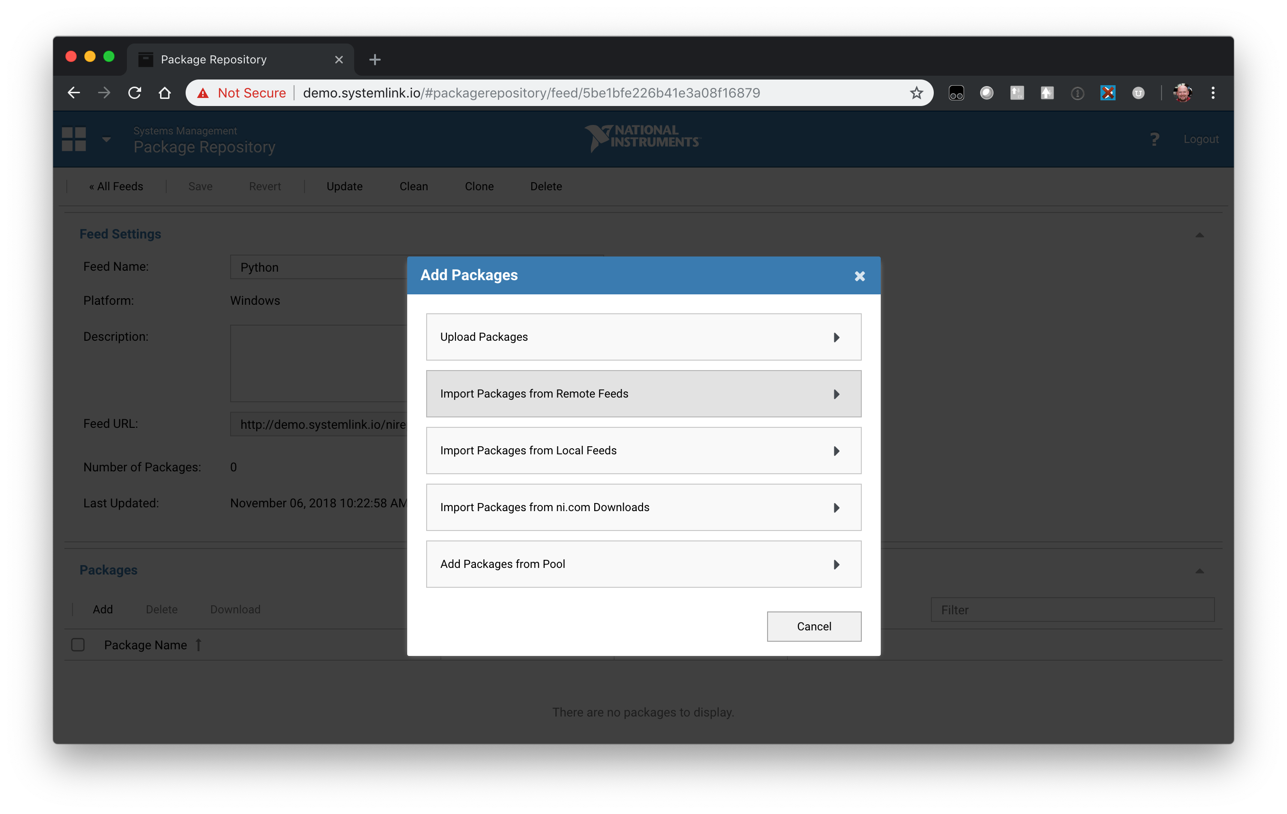
      6. Specify the following URL - <http://download.ni.com/support/nipkg/products/ni-s/ni-systemlink-server/18.2/released>
      7. 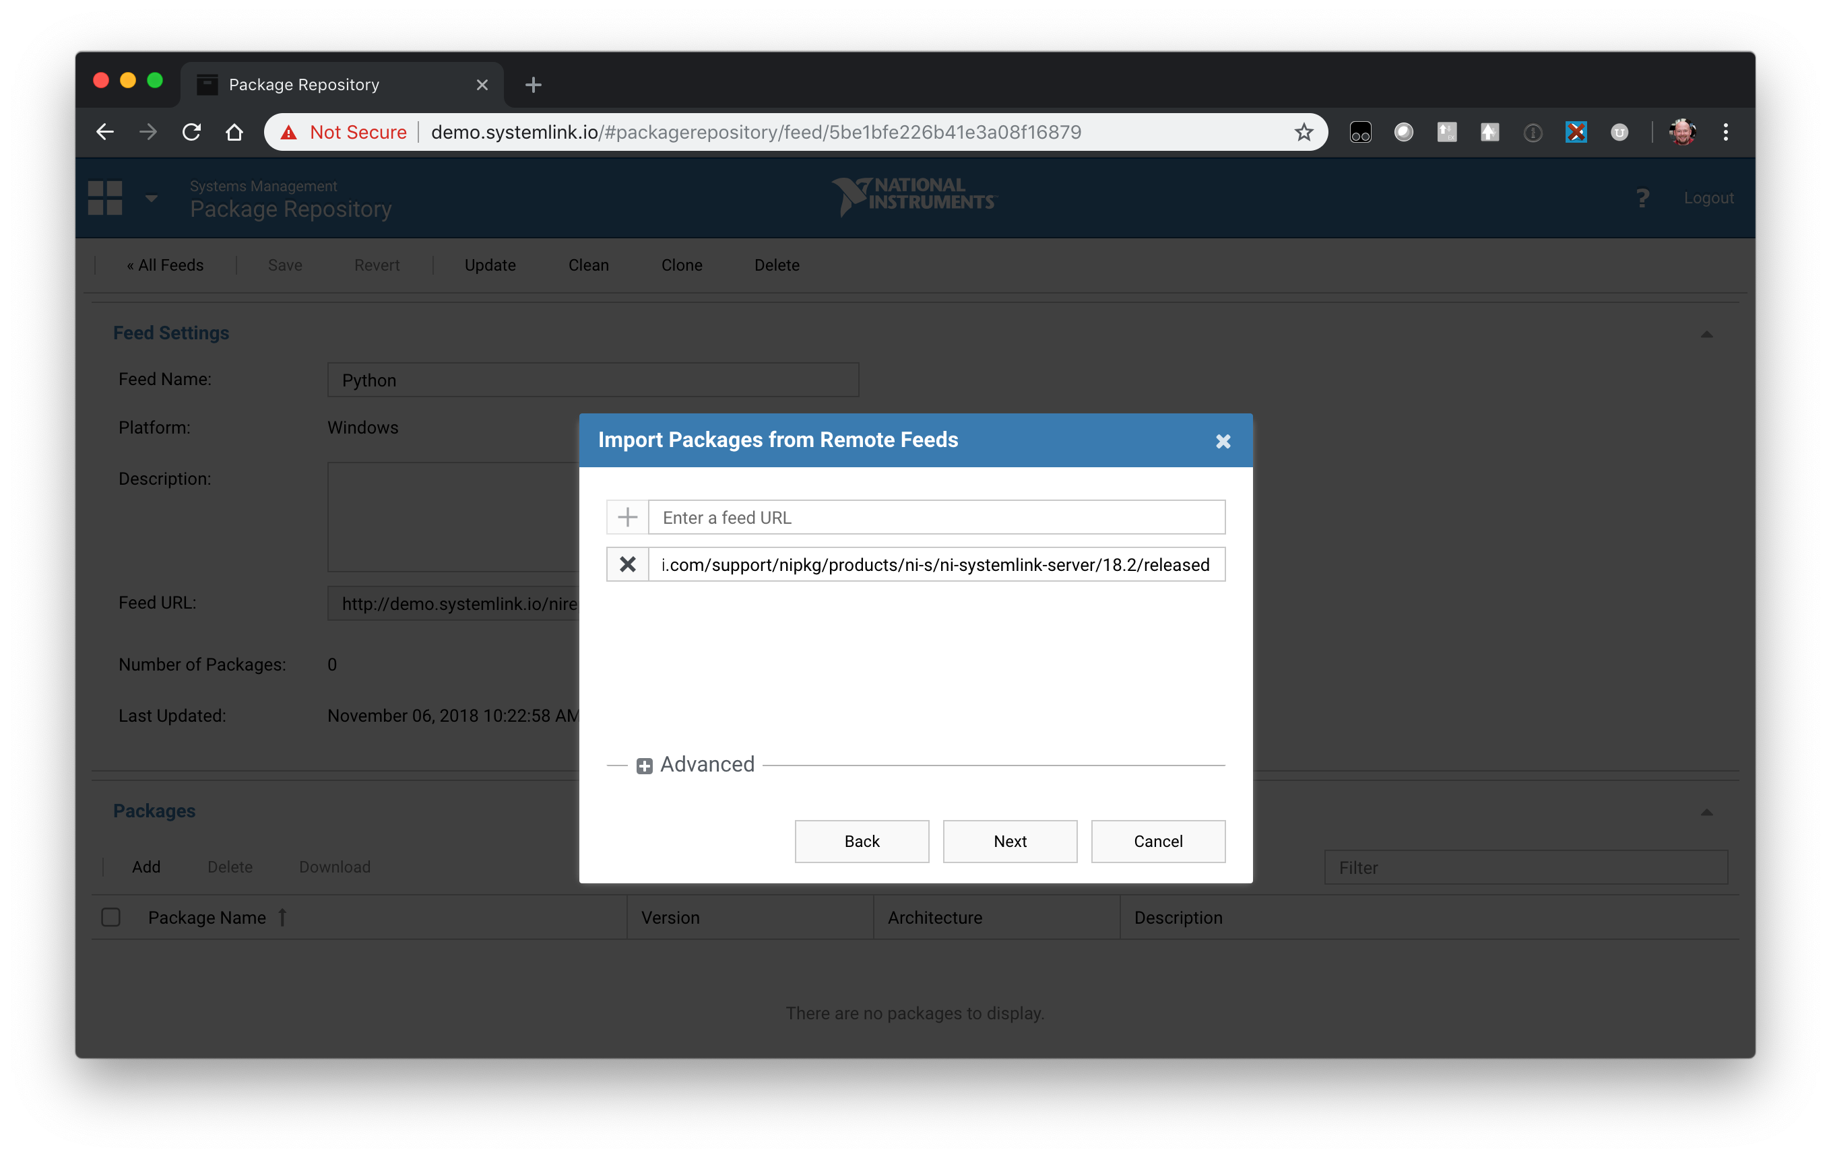
      8. Use the check-box at the top to unselect everything, then search for Python and select the ni-systemlink-python-3.6 package to Import.
      9. 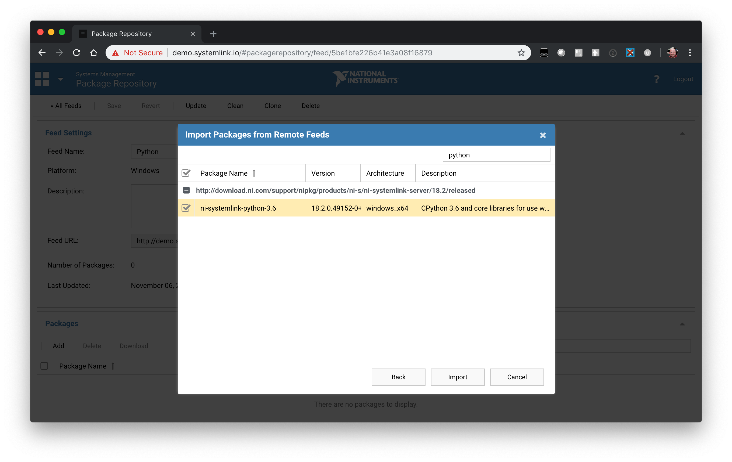
      10. Now you should have a feed hosted from your SL Server with the Python support. Next, we will use the Systems Manager application to deploy it.
      11. Launch Systems Manager and click on the Managed Systems application.
      12. Select the systems you wish to install the Python support on and click on the Software button in the toolbar
      13. 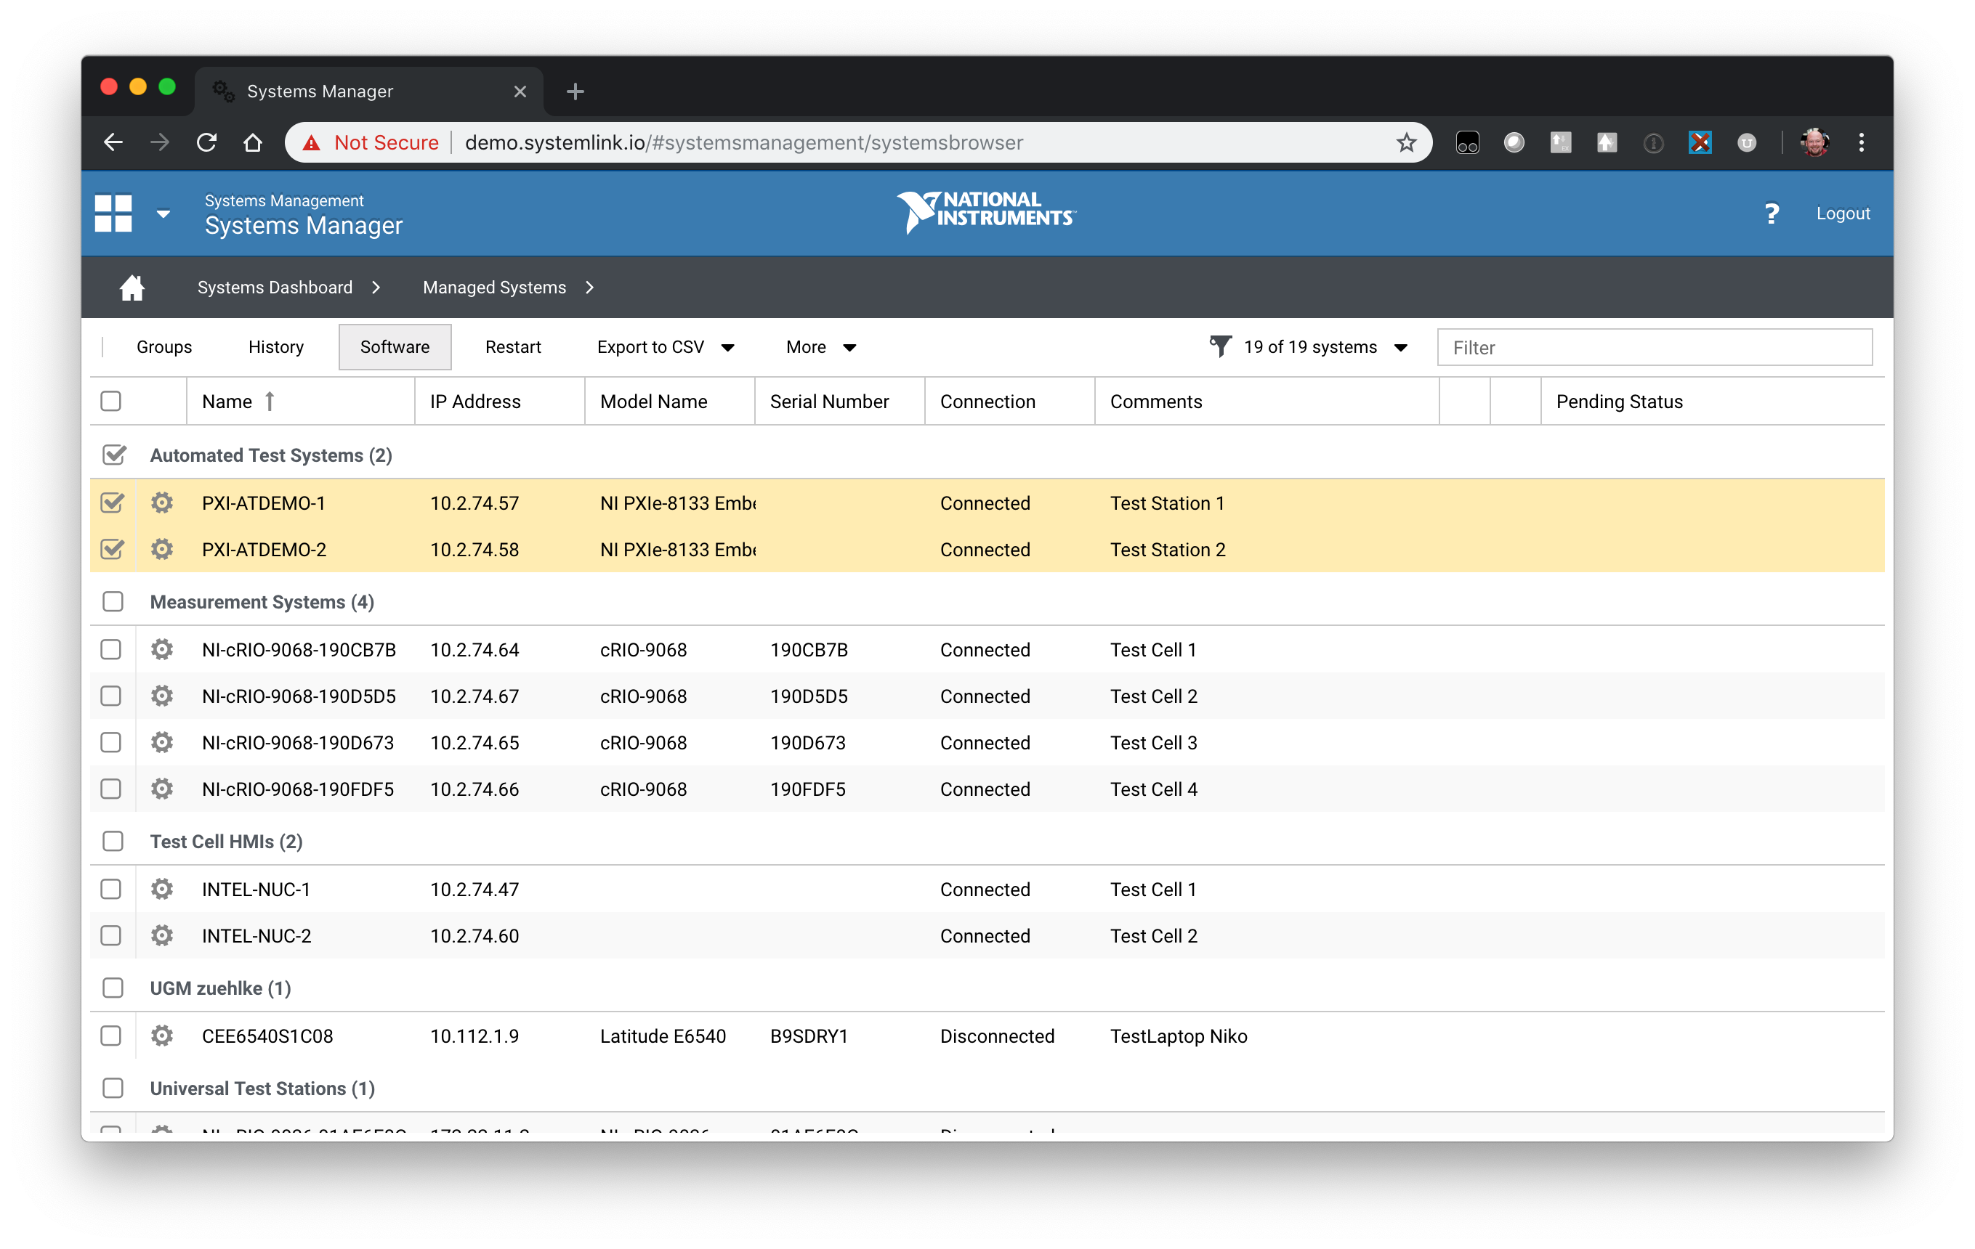
      14. From the Software dialog choose the Feeds tab and click on the Add button and choose “Add from Package Repository”
      15. 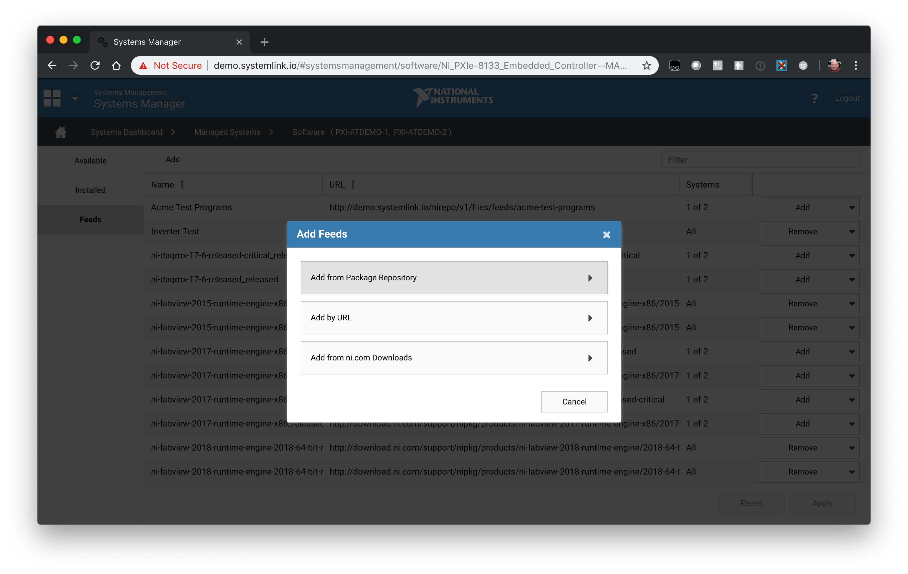
      16. Select your “SystemLink Python Support” you created previously. Note this is what will enable these systems to install software from this feed.
      17. 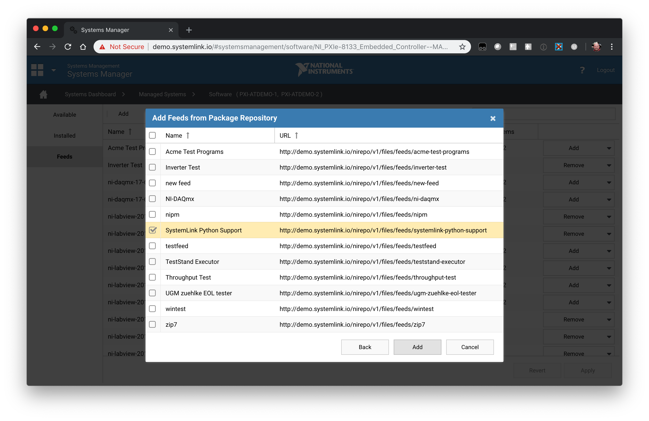
      18. Click Apply and then select the Available Tab
      19. 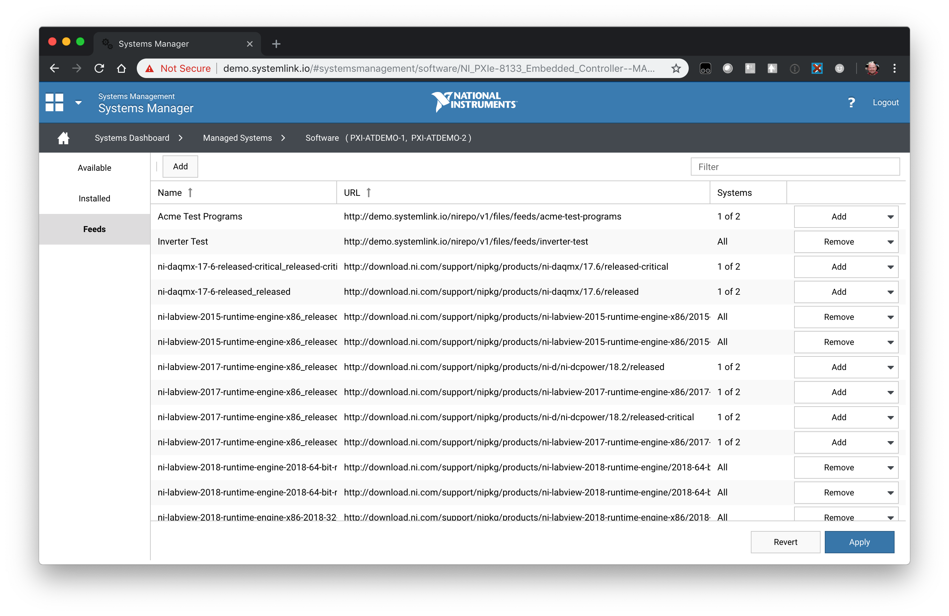
      20. From the Available tab click on the View button and select the “Hidden” option. Note the SL Python support is currently marked as an infrastructure component, so it is only installed with our Jupyter support today, however it will be split out to a user visible option in the future and included with the SystemLink Client by default.
      21. 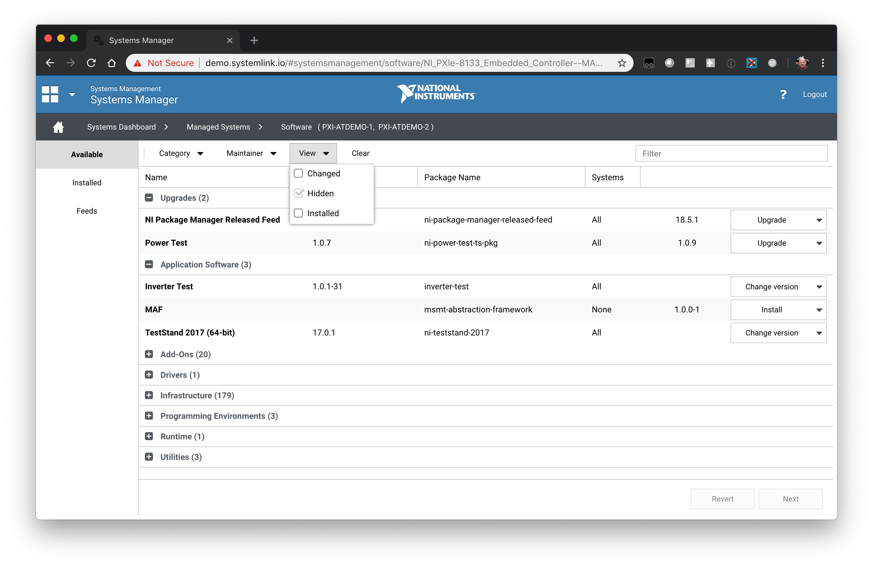
      22. In the upper right search for “python” and click Install next to the “NI SystemLink Python 3.6” package.
      23. 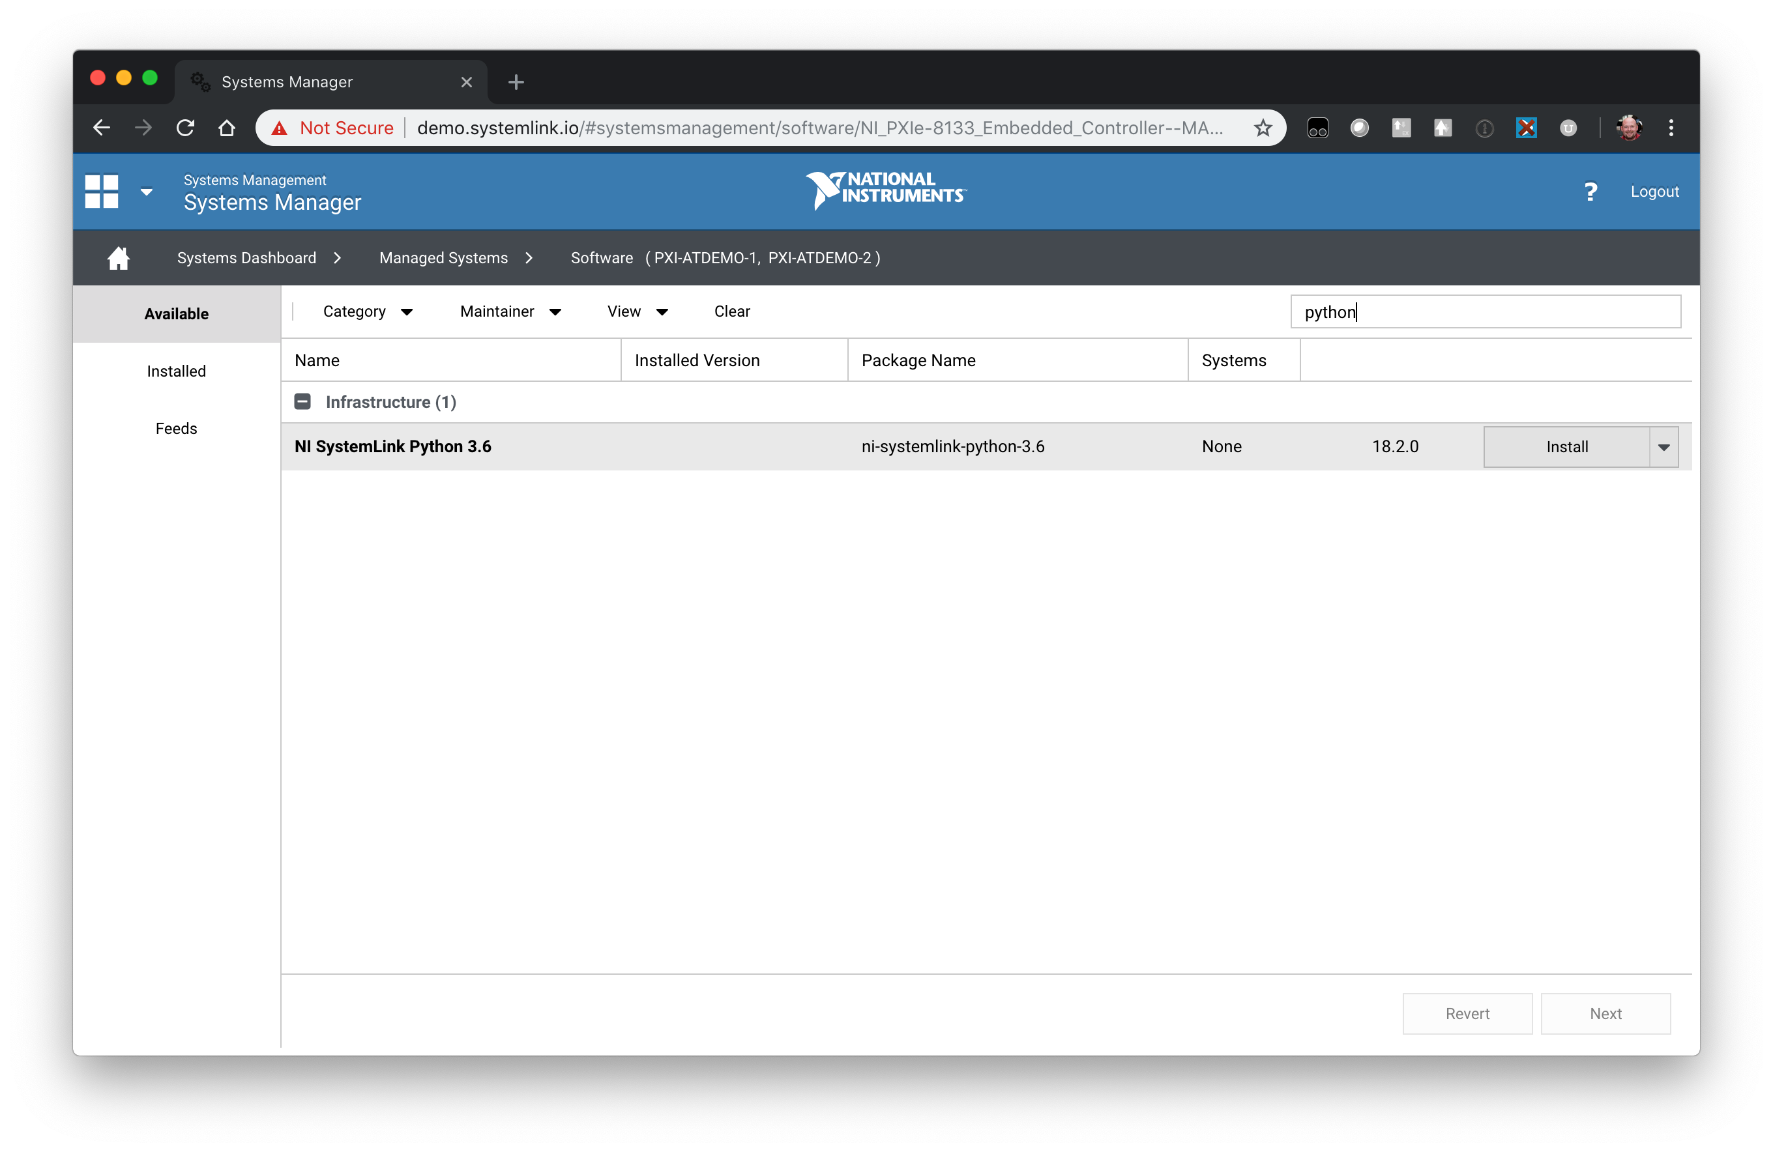
      24. It should take around 10-30 minutes to deploy depending on your network bandwidth and disk speed on your remote systems. This will install an entire Python 3.6 distribution including the packages for the SL APIs and our dependencies.
      25. 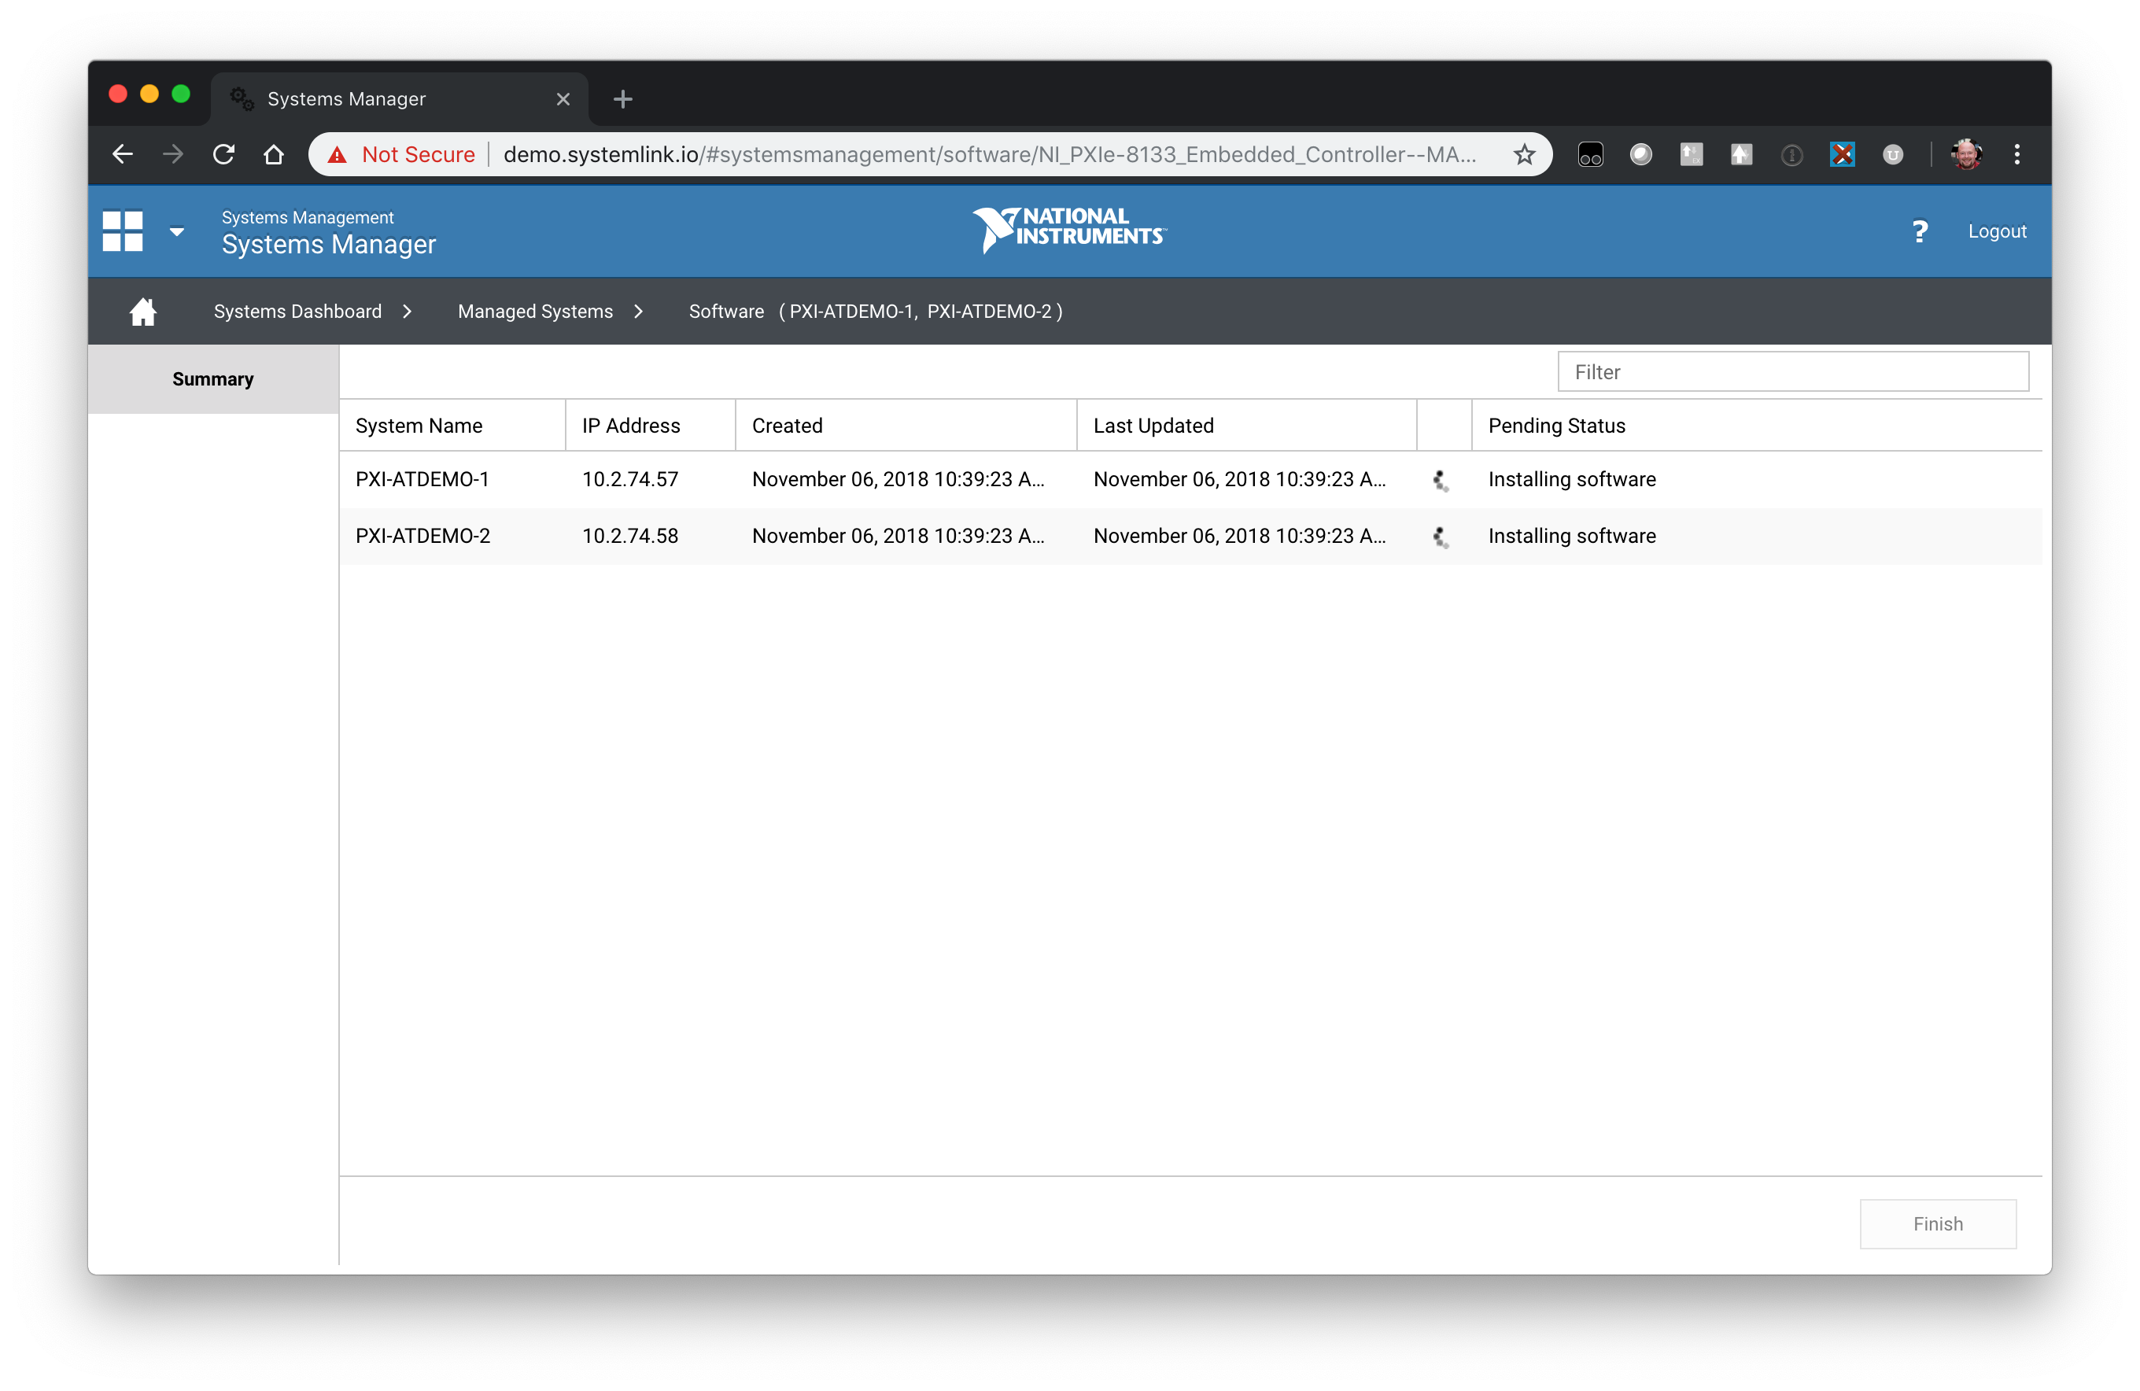
2. Using the SystemLink Python API
   1. Log into a target that has the Python API installed
   2. Download the following Python example from <https://github.com/joshuaprewitt/systemlink-python-examples/blob/master/python/tag/tag%20example.py>
   3. 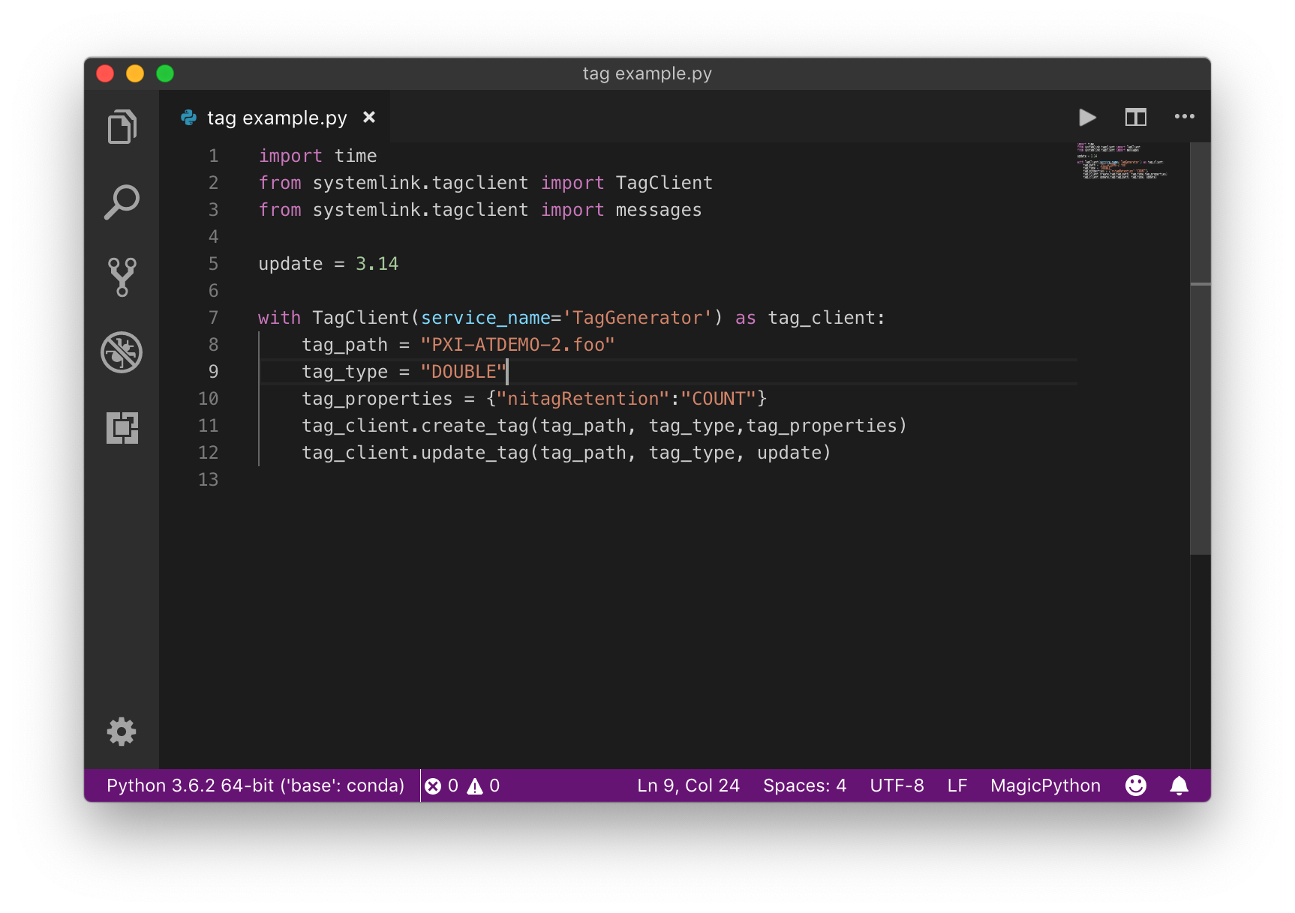
   4. Open a command prompt to c:\Program Files\National Instruments\Shared\Skyline\Python\3.6
   5. Run “python.exe <path to your example>”
   6. 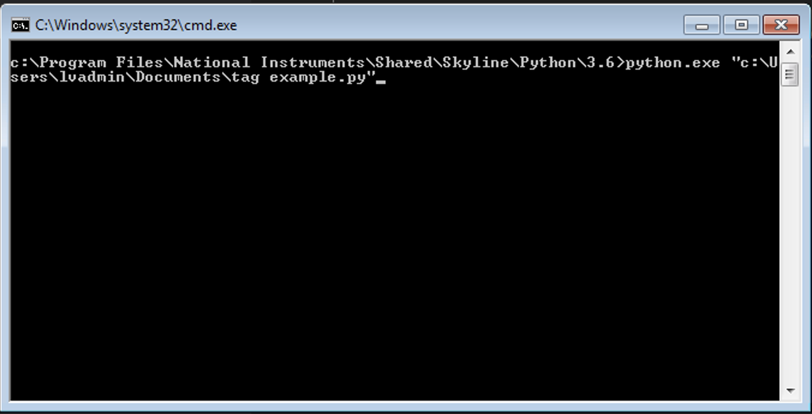
   7. Open the Tag Viewer to verify the tag was created and updated
   8. 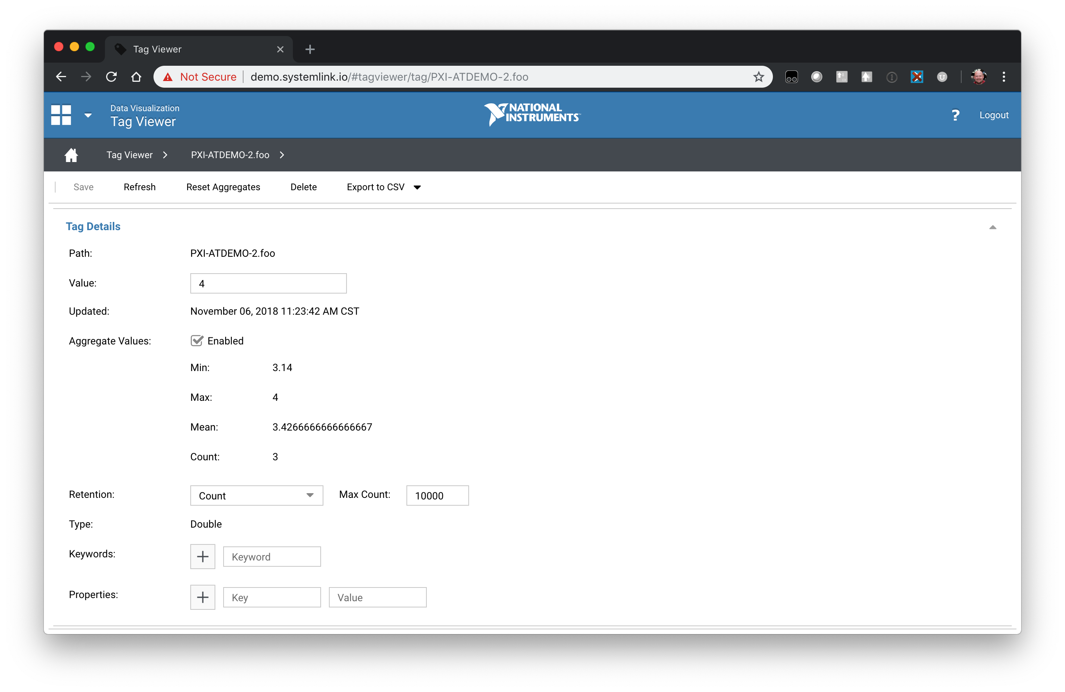
   9. Note you can see the full Tag Python API at C:\Program Files\National Instruments\Shared\Skyline\Python\3.6\Lib\site-packages\systemlink\tagclient\__init__.py